**Creating Service Credentials**

|  |  |
| --- | --- |
| Date | 16 Nov 2022 |
| Team ID | PNT2022TMID34450 |
| Project Name | Virtual Eye - Life Guard For Swimming Pools To Detect Active Drowning |

1. To create the connection information that My application needs to connect to the instance, click New credential.
2. Enter a name for the new credential in the Add new credential window.
3. Accept the Manager role.
4. (Optional) Create a service ID or have one automatically generated for me.
5. (Optional) Add inline configuration parameters. This parameter isn't used by IBM Cloudant service credentials, so ignore it.
6. Click Add.

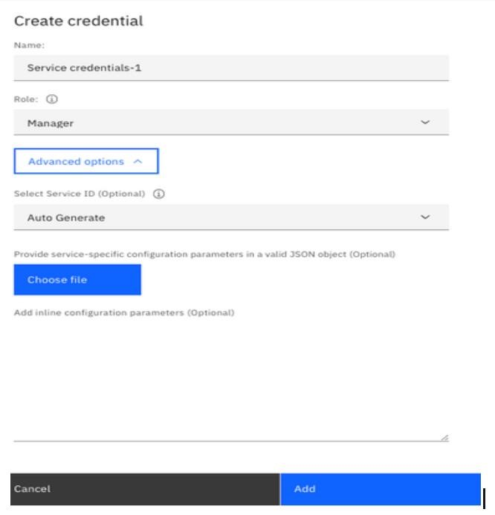

1. To see the credentials that are required to access the service, click the chevron.
2. The details for the service credentials open

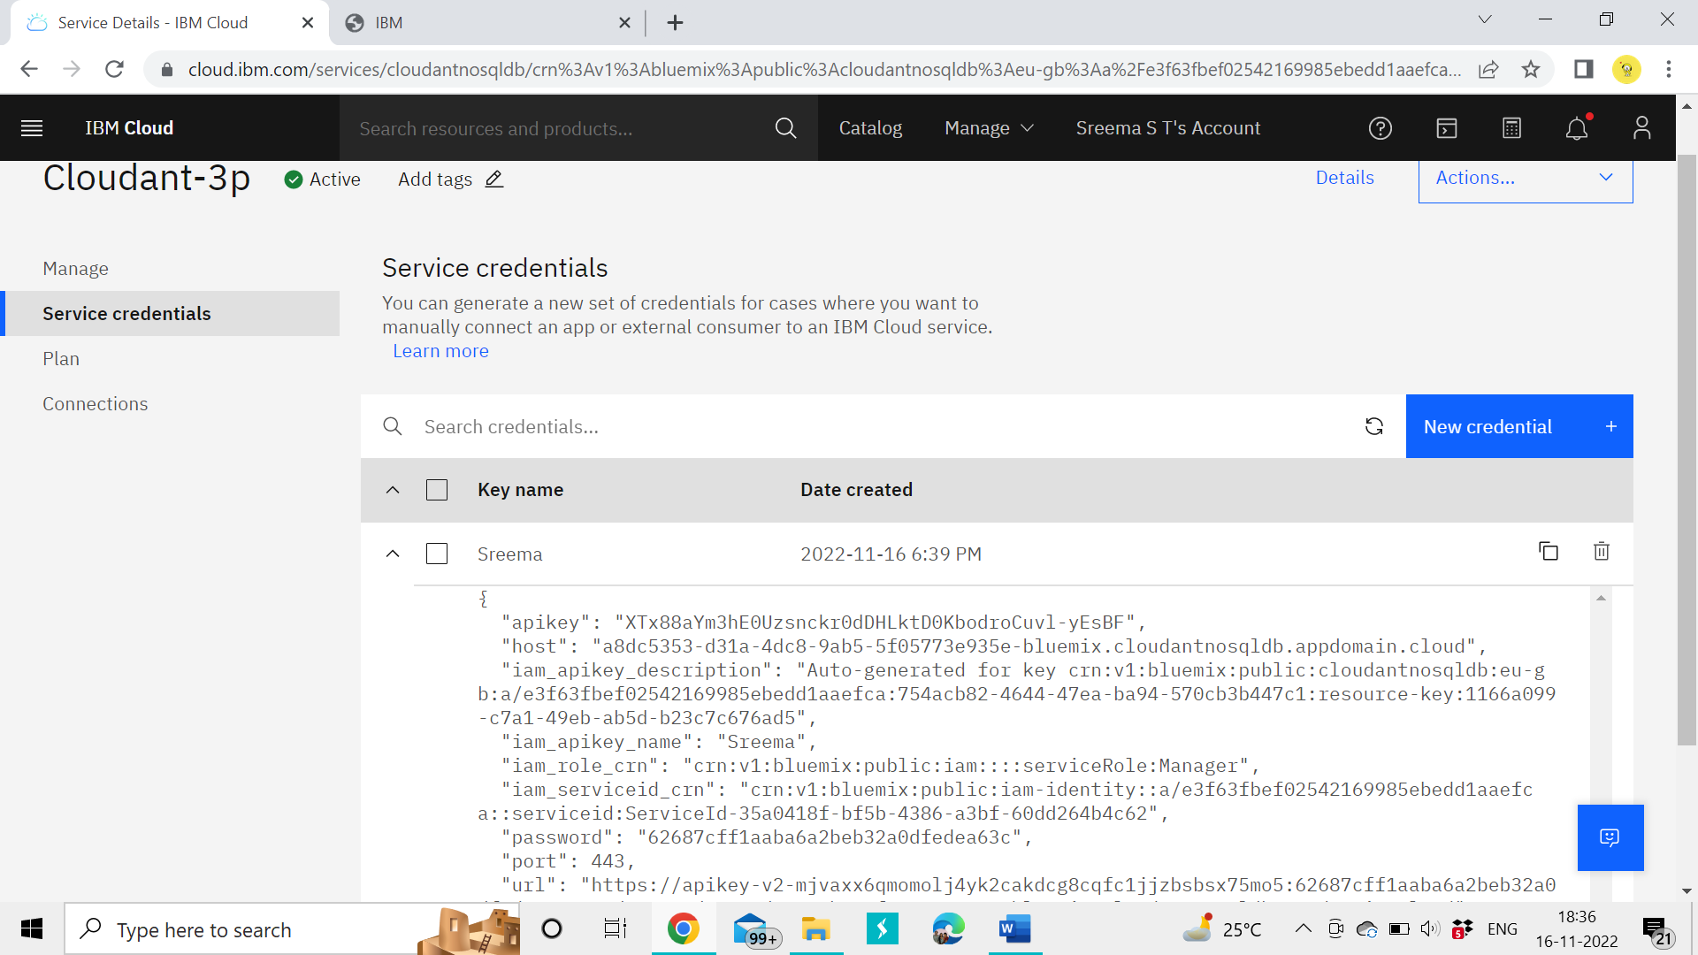

• Same procedure followed by my team members

**Team ID** : PNT2022TMID34450

**Team Leader** : Jone Abutelin B

**Team Member1**: Femi Priya K.C

**Team Member2**: Sreema S.T

**Team Member3**: Suthi R